Ansökan om Low Visibility Operations, LVO

Ver. 2019-08-27
Operatör:
Tillståndsnummer: |  |  | Ifylld EASA Form 2
 |  |  | ☐
 |  |  |  | Bilaga nummer
Relevant elements defined in the mandatory part of the operational suitability data established in accordance with Regulation (EU) No 748/2012 are taken into account

Transportstyrelsen
Ärendenummer: |  |  | Handläggare:
Berörda sektioner/samråd:

Information
Denna checklista är avsedd som stöd vid ansökan om flygning i låga siktvärden, Low Visibility Operations (LVO).
De specialtillstånd som kräver godkännande är:
LTS CAT I, CAT II, OTS CAT II, CAT IIIA/B/C, LVTO och Approach operation utilising enhanced vision systems (EVS)

Definition LVTO:
Low visibility take-off (LVTO) means a take-off with an RVR lower than 400 m but not less than 75 m.
For take-off in visibility lower than 400 m, special approval from Authority is required.
- LVTO ≤ 150 m (aircraft Category A, B, C and D)
- LVTO 75 m (aircraft equipped with HUD/HUDLS)

Utöver Del-SPA är CAT.OP.MPA.305, Commencement and continuation of approach inlagd i slutet av checklistan då denna regelpunkt är relevant vid flygning i låga siktvärden (för operatörer med AOC).
Ange var i det operativa manualverket (eller i annat styrande dokument) momentet återfinns och detta så detaljerat som möjligt för att underlätta och påskynda granskning och handläggning.
Om en punkt inte är relevant, markera rutan med N/A.

Där grönmarkerade rutor förekommer ska relevanta bilagor sändas in.
Bilagans nummer ska anges i checklistan.

SPA.LVO.100 Low Visibility operations
The operator shall only conduct the following low visibility operations (LVO) when approved by the
competent authority:
 |  | Applicerbart? |  | TS notering:
(a) low visibility take-off (LVTO) operation;
 |  | Applicerbart? |  | TS notering:
(b) lower than standard category I (LTS CAT I) operation;
 |  | Applicerbart? |  | TS notering:
(c) standard category II (CAT II) operation;
 |  | Applicerbart? |  | TS notering:
(d) other than standard category II (OTS CAT II) operation;
 |  | Applicerbart? |  | TS notering:
(e) standard category III (CAT III) operation;
 |  | Applicerbart? |  | TS notering:
(f) approach operation utilising enhanced vision systems (EVS) for which an operational credit is applied to reduce the runway visual range (RVR) minima by no more than one third of the published RVR.

AMC1 SPA.LVO.100 Low visibility operations

LVTO OPERATIONS - AEROPLANES
For a low visibility take-off (LVTO) with an aeroplane the following provisions should apply:
 |  | Detaljerade referenser: |  | TS notering:
(a) for an LVTO with a runway visual range (RVR) below 400 m the criteria specified in Table 1.A;
 |  | Detaljerade referenser: |  | TS notering:
(b) for an LVTO with an RVR below 150 m but not less than 125 m:
(1) high intensity runway centre line lights spaced 15 m or less apart and high intensity edge lights spaced 60 m or less apart that are in operation;
(2) a 90 m visual segment that is available from the flight crew compartment at the start of the take-off run; and
 |  | Detaljerade referenser: |  | TS notering:
(3) the required RVR value is achieved for all of the relevant RVR reporting points;
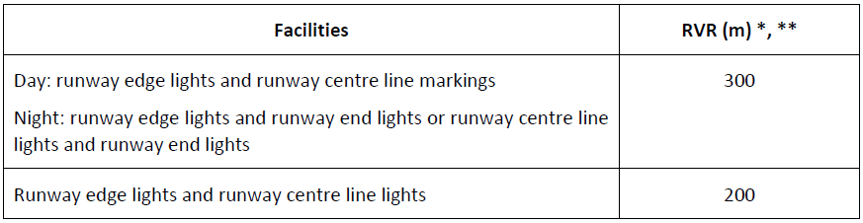
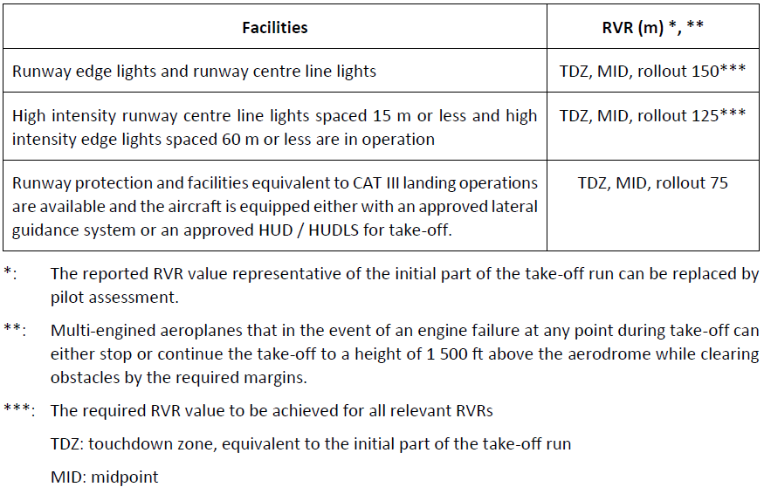

AMC2 SPA.LVO.100 Low visibility operations

LVTO OPERATIONS - HELICOPTERS
 |  | Detaljerade referenser: |  | TS notering:
For LVTOs with helicopters the provisions specified in Table 1.H should apply.
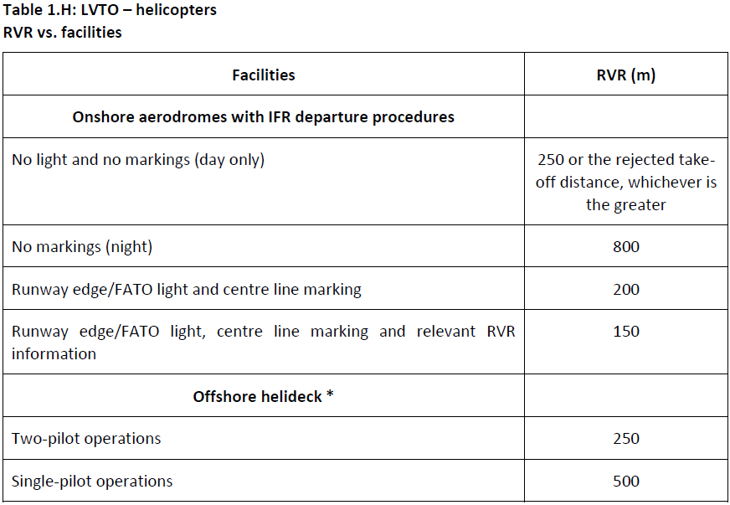

AMC3 SPA.LVO.100 Low visibility operations

LTS CAT I OPERATIONS
(a) For lower than Standard Category I (LTS CAT I) operations the following provisions should apply:
 |  | Detaljerade referenser: |  | TS notering:
(1) The decision height (DH) of an LTS CAT I operation should not be lower than the highest of:
(i) the minimum DH specified in the AFM, if stated;
(ii) the minimum height to which the precision approach aid can be used without the specified visual reference;
(iii) the applicable obstacle clearance height (OCH) for the category of aeroplane;
(iv) the DH to which the flight crew is qualified to operate; or
(v) 200 ft.
 |  | Detaljerade referenser: |  | TS notering:
(2) An instrument landing system / microwave landing system (ILS/MLS) that supports an LTS CAT I operation should be an unrestricted facility with a straight-in course, ≤ 3º offset, and the ILS should be certified to:
(i) class I/T/1 for operations to a minimum of 450 m RVR; or
(ii) class II/D/2 for operations to less than 450 m RVR.
Single ILS facilities are only acceptable if level 2 performance is provided.
 |  | Detaljerade referenser: |  | TS notering:
(3) The following visual aids should be available:
(i) standard runway day markings, approach lights, runway edge lights, threshold lights and runway end lights;
(ii) for operations with an RVR below 450 m, additionally touch-down zone and/or runway centre line lights.
 |  | Detaljerade referenser: |  | TS notering:
(4) The lowest RVR / converted meteorological visibility (CMV) minima to be used are specified
in Table 2.
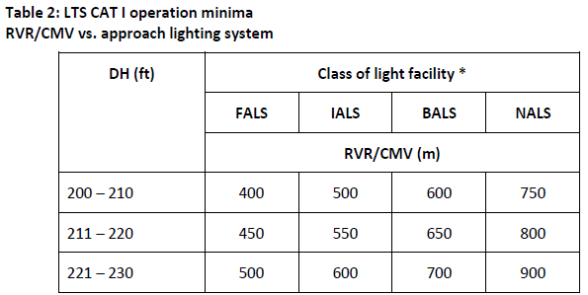
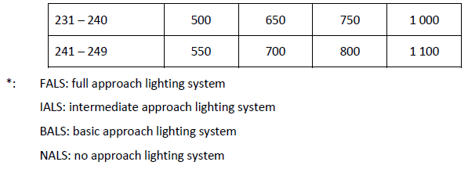

AMC4 SPA.LVO.100 Low visibility operations

CAT II and OTS CAT II OPERATIONS
(a) For CAT II and other than Standard Category II (OTS CAT II) operations the following provisions should apply:
 |  | Detaljerade referenser: |  | TS notering:
(1) The ILS / MLS that supports OTS CAT II operation should be an unrestricted facility with a straight in course (≤ 3º offset) and the ILS should be certified to class II/D/2.
Single ILS facilities are only acceptable if level 2 performance is provided.
 |  | Detaljerade referenser: |  | TS notering:
(2) The DH for CAT II and OTS CAT II operation should not be lower than the highest of:
(i) the minimum DH specified in the AFM, if stated;
(ii) the minimum height to which the precision approach aid can be used without the specified visual reference;
(iii) the applicable OCH for the category of aeroplane;
(iv) the DH to which the flight crew is qualified to operate; or
(v) 100 ft.
 |  | Detaljerade referenser: |  | TS notering:
(3) The following visual aids should be available:
(i) standard runway day markings and approach and the following runway lights: runway edge lights, threshold lights and runway end lights;
(ii) for operations in RVR below 450 m, additionally touch-down zone and/or runway centre line lights;
(iii) for operations with an RVR of 400 m or less, additionally centre line lights.
 |  | Detaljerade referenser: |  | TS notering:
(4) The lowest RVR minima to be used are specified:
(i) for CAT II operations in Table 3; and
(ii) for OTS CAT II operations in Table 4.
 |  | Detaljerade referenser: |  | TS notering:
(b) For OTS CAT II operations, the terrain ahead of the runway threshold should have been surveyed.
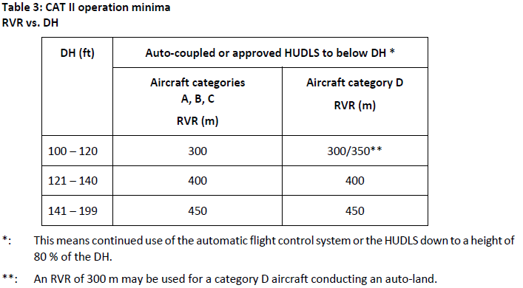
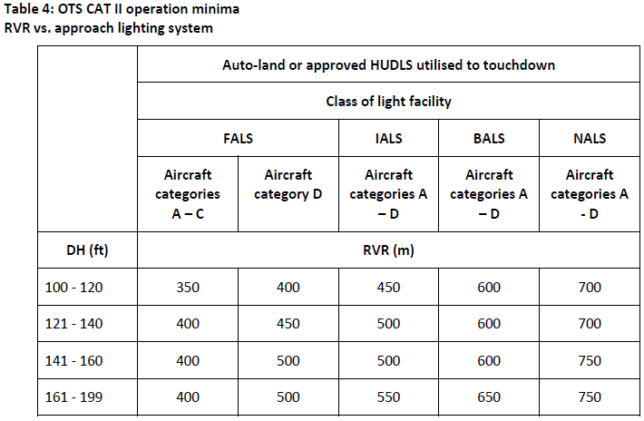

AMC5 SPA.LVO.100 Low visibility operations

CAT III OPERATIONS
The following provisions should apply to CAT III operations:
 |  | Detaljerade referenser: |  | TS notering:
(a) Where the DH and RVR do not fall within the same category, the RVR should determine in which
category the operation is to be considered.
 |  | Detaljerade referenser: |  | TS notering:
(b) For operations in which a DH is used, the DH should not be lower than:
(1) the minimum DH specified in the AFM, if stated;
(2) the minimum height to which the precision approach aid can be used without the specified
visual reference; or
(3) the DH to which the flight crew is qualified to operate.
 |  | Detaljerade referenser: |  | TS notering:
(c) Operations with no DH should only be conducted if:
(1) the operation with no DH is specified in the AFM;
(2) the approach aid and the aerodrome facilities can support operations with no DH; and
(3) the flight crew is qualified to operate with no DH.
 |  | Detaljerade referenser: |  | TS notering:
(d) The lowest RVR minima to be used are specified in Table 5.
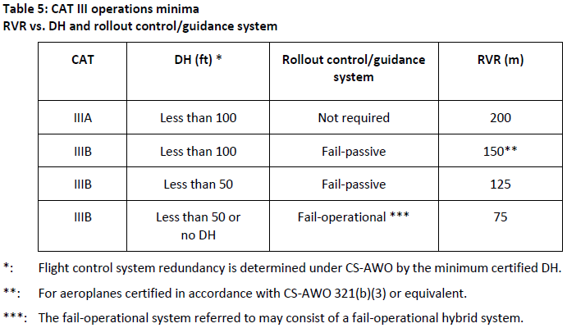

AMC6 SPA.LVO.100 Low visibility operations

OPERATIONS UTILISING EVS
The pilot using a certified enhanced vision system (EVS) in accordance with the procedures and limitations of the AFM:
 |  | Detaljerade referenser: |  | TS notering:
(a) may reduce the RVR/CMV value in column 1 to the value in column 2 of Table 6 for CAT I operations, APV operations and NPA operations flown with the CDFA technique;
 |  | Detaljerade referenser: |  | TS notering:
(b) for CAT I operations:
(1) may continue an approach below DH to 100 ft above the runway threshold elevation provided that a visual reference is displayed and identifiable on the EVS image; and
(2) should only continue an approach below 100 ft above the runway threshold elevation provided that a visual reference is distinctly visible and identifiable to the pilot without reliance on the EVS;
 |  | Detaljerade referenser: |  | TS notering:
(c) for APV operations and NPA operations flown with the CDFA technique:
(1) may continue an approach below DH/MDH to 200 ft above the runway threshold elevation provided that a visual reference is displayed and identifiable on the EVS image; and
(2) should only continue an approach below 200 ft above the runway threshold elevation provided that a visual reference is distinctly visible and identifiable to the pilot without reliance on the EVS.
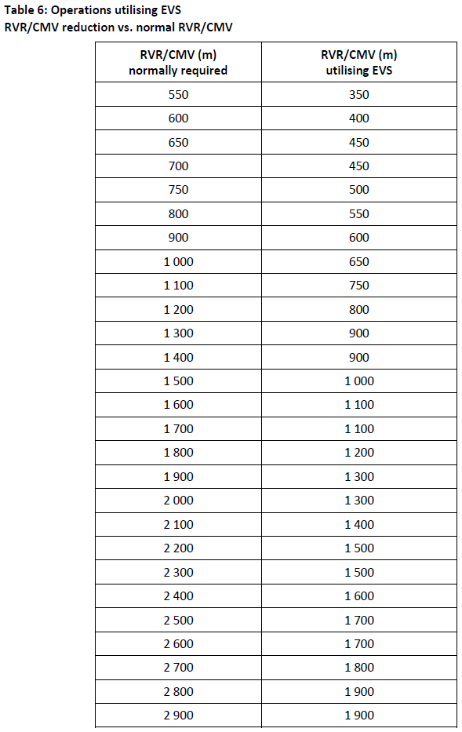
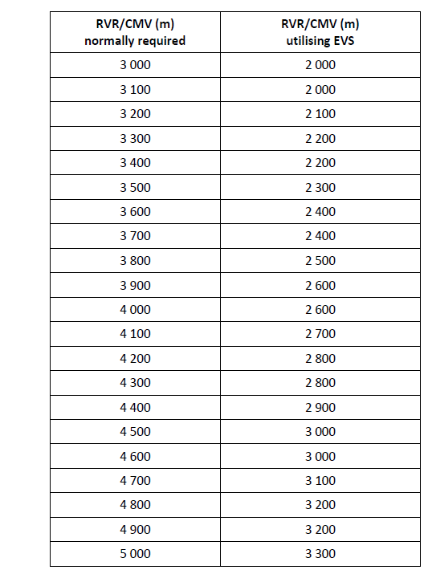

AMC7 SPA.LVO.100 Low visibility operations

EFFECT ON LANDING MINIMA OF TEMPORARILY FAILED OR DOWNGRADED EQUIPMENT
 |  | Detaljerade referenser: |  | TS notering:
(a) General
These instructions are intended for use both pre-flight and in-flight. It is however not expected that the pilot-in-command/commander would consult such instructions after passing 1 000 ft above the aerodrome. If failures of ground aids are announced at such a late stage, the approach could be continued at the pilot-in-command/commander’s discretion. If failures are announced before such a late stage in the approach, their effect on the approach should be considered as described in Table 7, and the approach may have to be abandoned.
 |  | Detaljerade referenser: |  | TS notering:
(b) The following conditions should be applicable to the tables below:
(1) multiple failures of runway/FATO lights other than indicated in Table 7 are not acceptable;
(2) deficiencies of approach and runway/FATO lights are treated separately;
(3) for CAT II and CAT III operations, a combination of deficiencies in runway/FATO lights and RVR assessment equipment are not permitted; and
(4) failures other than ILS and MLS affect RVR only and not DH.
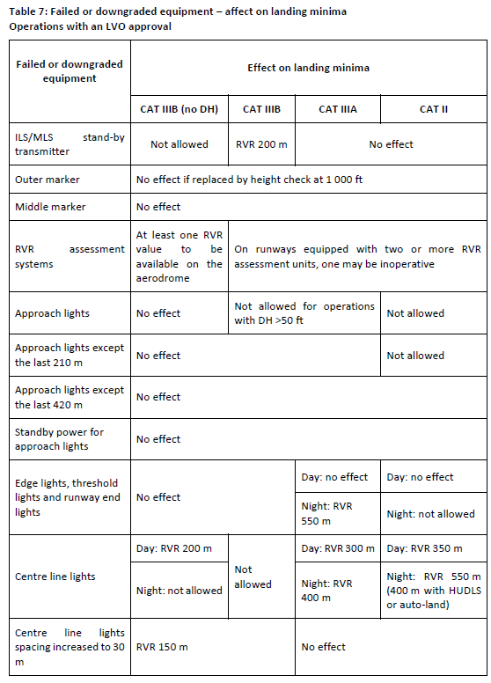
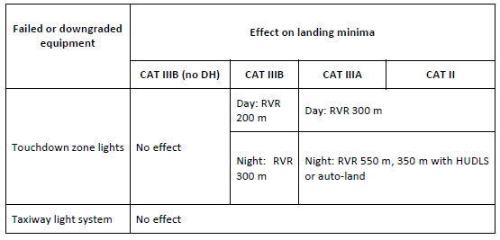

GM1 SPA.LVO.100 Low visibility operations

DOCUMENTS CONTAINING INFORMATION TO LOW VISIBILITY OPERATIONS
The following documents provide further information to low visibility operations (LVO):
(a) ICAO Annex 2 Rules of the Air;
(b) ICAO Annex 6 Operation of Aircraft;
(c) ICAO Annex 10 Telecommunications Vol. 1;
(d) ICAO Annex 14 Aerodromes Vol. 1;
(e) ICAO Doc 8168 PANS - OPS Aircraft Operations;
(f) ICAO Doc 9365 AWO Manual;
(g) ICAO Doc 9476 Manual of surface movement guidance and control systems (SMGCS);
(h) ICAO Doc 9157 Aerodrome Design Manual;
(i) ICAO Doc 9328 Manual of RVR Observing and Reporting Practices;
(j) ICAO EUR Doc 013: European Guidance Material on Aerodrome Operations under Limited Visibility
Conditions;
(k) ECAC Doc 17, Issue 3; and
(l) CS-AWO All weather operations.

GM2 SPA.LVO.100 Low visibility operations

ILS CLASSIFICATION
The ILS classification system is specified in ICAO Annex 10.

GM1 SPA.LVO.100(c),(e) Low visibility operations

ESTABLISHMENT OCH MINIMUM RVR FOR CAT II AND CAT III OPERATIONS
För uttömmande text refereras till regelverket.
- General
- CAT II operations
- CAT III fail-passive operations
- CAT III fail-operational operations – with a DH
- CAT III fail-operational operations – with no DH

GM1 SPA.LVO.100(e) Low visibility operations

CREW ACTIONS IN CASE OF AUTOPILOT FAILURE AT OR BELOW DH IN FAIL-PASSIVE CAT III OPERATIONS
For operations to actual RVR values less than 300 m, a missed approach procedure is assumed in the event of an autopilot failure at or below DH. This means that a missed approach procedure is the normal action. However, the wording recognises that there may be circumstances where the safest action is to continue the landing. Such circumstances include the height at which the failure occurs, the actual visual references, and other malfunctions. This would typically apply to the late stages of the flare. In conclusion, it is not forbidden to continue the approach and complete the landing when the pilot-incommand/commander determines that this is the safest course of action. The operator’s policy and the operational instructions should reflect this information.

GM1 SPA.LVO.100(f) Low visibility operations

OPERATIONS UTILISING EVS
För uttömmande text refereras till regelverket.
- Introduction
- Background to EVS provisions
- Additional operational considerations

SPA.LVO.105 LVO approval
To obtain an LVO approval from the competent authority, the operator shall demonstrate compliance
with the requirements of this Subpart.

AMC1 SPA.LVO.105 LVO approval

OPERATIONAL DEMONSTRATION - AEROPLANES
(a) General
(1) The purpose of the operational demonstration should be to determine or validate the use and effectiveness of the applicable aircraft flight guidance systems, including HUDLS if appropriate, training, flight crew procedures, maintenance programme, and manuals applicable to the CAT II/III programme being approved.
 |  | Bilaga nummer: |  | TS notering:
(i) At least 30 approaches and landings should be accomplished in operations using the CAT II/III systems installed in each aircraft type if the requested DH is 50 ft or higher. If the DH is less than 50 ft, at least 100 approaches and landings should be accomplished.
 |  | Bilaga nummer: |  | TS notering:
(ii) If the operator has different variants of the same type of aircraft utilising the same basic flight control and display systems, or different basic flight control and display systems on the same type of aircraft, the operator should show that the various variants have satisfactory performance, but need not conduct a full operational demonstration for each variant. The number of approaches and landings may be based on credit given for the experience gained by another operator, using the same aeroplane type or variant and procedures.
 |  | Bilaga nummer: |  | TS notering:
(iii) If the number of unsuccessful approaches exceeds 5 % of the total, e.g. unsatisfactory landings, system disconnects, the evaluation programme should be extended in steps of at least 10 approaches and landings until the overall failure rate does not exceed 5 %.
 |  | Bilaga nummer: |  | TS notering:
(2) The operator should establish a data collection method to record approach and landing performance. The resulting data and a summary of the demonstration data should be made available to the competent authority for evaluation.
 |  | Bilaga nummer: |  | TS notering:
(3) Unsatisfactory approaches and/or automatic landings should be documented and analysed.
(b) Demonstrations
(1) Demonstrations may be conducted in line operations or any other flight where the operator's procedures are being used.
 |  | Bilaga nummer: |  | TS notering:
(2) In unique situations where the completion of 100 successful landings could take an unreasonably long period of time and equivalent reliability assurance can be achieved, a reduction in the required number of landings may be considered on a case-by-case basis. Reduction of the number of landings to be demonstrated requires a justification for the reduction. This justification should take into account factors such as a small number of aircraft in the fleet, limited opportunity to use runways having CAT II/III procedures or the inability to obtain ATS sensitive area protection during good weather conditions. However,
at the operator's option, demonstrations may be made on other runways and facilities.
Sufficient information should be collected to determine the cause of any unsatisfactory performance (e.g. sensitive area was not protected).
 |  | Bilaga nummer: |  | TS notering:
(3) If the operator has different variants of the same type of aircraft utilising the same basic flight control and display systems, or different basic flight control and display systems on the same type or class of aircraft, the operator should show that the various variants have satisfactory performance, but need not conduct a full operational demonstration for each variant.
 |  | Bilaga nummer: |  | TS notering:
(4) Not more than 30 % of the demonstration flights should be made on the same runway.
 |  | Detaljerade referenser: |  | TS notering:
(c) Data collection for operational demonstrations
(1) Data should be collected whenever an approach and landing is attempted utilising the CAT II/III system, regardless of whether the approach is abandoned, unsatisfactory, or is concluded successfully.
 |  | Detaljerade referenser: |  | TS notering:
(2) The data should, as a minimum, include the following information:
(i) Inability to initiate an approach. Identify deficiencies related to airborne equipment that preclude initiation of a CAT II/III approach.
(ii) Abandoned approaches. Give the reasons and altitude above the runway at which approach was discontinued or the automatic landing system was disengaged.
(iii) Touchdown or touchdown and rollout performance. Describe whether or not the aircraft landed satisfactorily within the desired touchdown area with lateral velocity
or cross track error that could be corrected by the pilot or automatic system so as to remain within the lateral confines of the runway without unusual pilot skill or
technique. The approximate lateral and longitudinal position of the actual touchdown point in relation to the runway centre line and the runway threshold,
respectively, should be indicated in the report. This report should also include any CAT II/III system abnormalities that required manual intervention by the pilot to ensure a safe touchdown or touchdown and rollout, as appropriate.
(d) Data analysis
 |  | Detaljerade referenser: |  | TS notering:
Unsuccessful approaches due to the following factors may be excluded from the analysis:
(1) ATS factors. Examples include situations in which a flight is vectored too close to the final approach fix/point for adequate localiser and glide slope capture, lack of protection of ILS sensitive areas, or ATS requests the flight to discontinue the approach.
(2) Faulty navaid signals. Navaid (e.g. ILS localiser) irregularities, such as those caused by other aircraft taxiing, over-flying the navaid (antenna).
(3) Other factors. Any other specific factors that could affect the success of CAT II/ III operations that are clearly discernible to the flight crew should be reported.

AMC2 SPA.LVO.105 LVO approval

OPERATIONAL DEMONSTRATION - HELICOPTERS
(a) The operator should comply with the provisions prescribed below when introducing into CAT II or III service a helicopter type that is new to the EU.
 |  | Bilaga nummer: |  | TS notering:
(1) Operational reliability
The CAT II and III success rate should not be less than that required by CS-AWO or equivalent.
 |  | Bilaga nummer: |  | TS notering:
(2) Criteria for a successful approach
An approach is regarded as successful if:
(i) the criteria are as specified in CS-AWO or equivalent are met; and
(ii) no relevant helicopter system failure occurs. For helicopter types already used for CAT II or III operations in another Member State, the in-service proving programme in (e) should be used instead.
(b) Data collection during airborne system demonstration - general
 |  | Bilaga nummer: |  | TS notering:
(1) The operator should establish a reporting system to enable checks and periodic reviews to be made during the operational evaluation period before the operator is approved to conduct CAT II or III operations. The reporting system should cover all successful and unsuccessful approaches, with reasons for the latter, and include a record of system component failures. This reporting system should be based upon flight crew reports and
automatic recordings as prescribed in (c) and (d) below.
(2) The recordings of approaches may be made during normal line flights or during other flights performed by the operator.
(c) Data collection during airborne system demonstration – operations with DH not less than 50 ft
 |  | Bilaga nummer: |  | TS notering:
(1) For operations with DH not less than 50 ft, data should be recorded and evaluated by the operator and evaluated by the competent authority when necessary.
 |  | Detaljerade referenser: |  | TS notering:
(2) It is sufficient for the following data to be recorded by the flight crew:
(i) FATO and runway used;
(ii) weather conditions;
(iii) time;
(iv) reason for failure leading to an aborted approach;
(v) adequacy of speed control;
(vi) trim at time of automatic flight control system disengagement;
(vii) compatibility of automatic flight control system, flight director and raw data;
(viii) an indication of the position of the helicopter relative to the ILS, MLS centre line when descending through 30 m (100 ft); and
(ix) touchdown position.
 |  | Bilaga nummer: |  | TS notering:
(3) The number of approaches made during the initial evaluation should be sufficient to demonstrate that the performance of the system in actual airline service is such that a 90 % confidence and a 95 % approach success will result.
(d) Data collection during airborne system demonstration – operations with DH less than 50 ft or no DH.
(1) For operations with DH less than 50 ft or no DH, a flight data recorder (FDR), or other equipment giving the appropriate information, should be used in addition to the flight crew reports to confirm that the system performs as designed in actual airline service. The following data should be recorded:

 |  | Bilaga nummer: |  | TS notering:
(i) distribution of ILS, MLS deviations at 30 m (100 ft), at touchdown and, if appropriate, at disconnection of the rollout control system and the maximum values of the
deviations between those points; and
(ii) sink rate at touchdown.
(e) In-service proving
The operator fulfilling the provisions of (f) above should be deemed to have met the in-service proving contained in this subparagraph.
 |  | Bilaga nummer: |  | TS notering:
(1) The system should demonstrate reliability and performance in line operations consistent with the operational concepts. A sufficient number of successful landings should be accomplished in line operations, including training flights, using the auto-land and rollout
system installed in each helicopter type.
 |  | Detaljerade referenser: |  | TS notering:
(2) The demonstration should be accomplished using a CAT II or CAT III ILS. Demonstrations may be made on other ILS or MLS facilities if sufficient data are recorded to determine the cause of unsatisfactory performance.
 |  | Detaljerade referenser: |  | TS notering:
(3) If the operator has different variants of the same type of helicopter utilising the same basic flight control and display systems, or different basic flight control and display systems on the same type of helicopter, the operator should show that the variants comply with the basic system performance criteria, but the operator need not conduct a full operational demonstration for each variant.
 |  | Detaljerade referenser: |  | TS notering:
(4) Where the operator introduces a helicopter type that has already been approved by the competent authority of any Member State for CAT II and/or CAT III operations, a reduced proving programme may be acceptable.

AMC3 SPA.LVO.105 LVO approval

CONTINOUS MONITORING – ALL AIRCRAFT
(a) After obtaining the initial approval, the operations should be continuously monitored by the operator to detect any undesirable trends before they become hazardous. Flight crew reports may be used to achieve this.
 |  | Bilaga nummer: |  | TS notering:
(b) The following information should be retained for a period of 12 months:
(1) the total number of approaches, by aircraft type, where the airborne CAT II or III equipment was utilised to make satisfactory, actual or practice, approaches to the applicable CAT II or III minima; and
 |  | Bilaga nummer: |  | TS notering:
(2) reports of unsatisfactory approaches and/or automatic landings, by aerodrome and aircraft registration, in the following categories:
(i) airborne equipment faults;
(ii) ground facility difficulties;
(iii) missed approaches because of ATC instructions; or
(iv) other reasons.
 |  | Detaljerade referenser: |  | TS notering:
(c) The operator should establish a procedure to monitor the performance of the automatic landing system or HUDLS to touchdown performance, as appropriate, of each aircraft.

AMC4 SPA.LVO.105 LVO approval

TRANSITIONAL PERIODS FOR CAT II AND CAT III OPERATIONS
(a) Operators with no previous CAT II or CAT III experience
 |  | Bilaga nummer: |  | TS notering:
(1) The operator without previous CAT II or III operational experience, applying for a CAT II or CAT IIIA operational approval, should demonstrate to the competent authority that it has gained a minimum experience of 6 months of CAT I operations on the aircraft type.
 |  | Bilaga nummer: |  | TS notering:
(2) The operator approved for CAT II or III operations using auto-coupled approach procedures, with or without auto-land, and subsequently introducing manually flown CAT II or III operations using a HUDLS should provide the operational demonstrations set out in AMC1 SPA.LVO.105 and AMC2 SPA.LVO.105 as if it would be a new applicant for a CAT II or CAT III approval.

AMC5 SPA.LVO.105 LVO approval

MAINTENANCE OF CAT II, CAT III AND LVTO EQUIPMENT
 |  | Bilaga nummer: |  | TS notering:
Maintenance instructions for the on-board guidance systems should be established by the operator, in
liaison with the manufacturer, and included in the operator's aircraft maintenance programme in accordance with Annex I to Regulation (EU) No 1321/2014.

AMC6 SPA.LVO.105 LVO approval

ELIGIBLE AERODROMES AND RUNWAYS
 |  | Bilaga nummer: |  | TS notering:
(a) Each aircraft type/runway combination should be verified by the successful completion of at least one approach and landing in CAT II or better conditions, prior to commencing CAT III operations.
 |  | Bilaga nummer: |  | TS notering:
(b) For runways with irregular pre-threshold terrain or other foreseeable or known deficiencies, each aircraft type/runway combination should be verified by operations in CAT I or better conditions, prior to commencing LTS CAT I, CAT II, OTS CAT II or CAT III operations.
 |  | Bilaga nummer: |  | TS notering:
(c) If the operator has different variants of the same type of aircraft in accordance with (d), utilising the same basic flight control and display systems, or different basic flight control and display systems on the same type of aircraft in accordance with (d), the operator should show that the
variants have satisfactory operational performance, but need not conduct a full operational demonstration for each variant/runway combination.
 |  | Bilaga nummer: |  | TS notering:
(d) For the purpose of this AMC, an aircraft type or variant of an aircraft type should be deemed to be the same type/variant of aircraft if that type/variant has the same or similar:
(1) level of technology, including the following:
(i) flight control/guidance system (FGS) and associated displays and controls;
(ii) FMS and level of integration with the FGS; and
(iii) use of HUDLS;
(2) operational procedures, including:
(i) alert height;
(ii) manual landing /automatic landing;
(iii) no DH operations; and
(iv) use of HUD/HUDLS in hybrid operations;
(3) handling characteristics, including:
(i) manual landing from automatic or HUDLS guided approach;
(ii) manual missed approach procedure from automatic approach; and
(iii) automatic/manual rollout.
 |  | Bilaga nummer: |  | TS notering:
(e) Operators using the same aircraft type/class or variant of a type in accordance with (d) above may take credit from each other’s experience and records in complying with this subparagraph.
 |  | Detaljerade referenser: |  | TS notering:
(f) Where an approval is sought for OTS CAT II, the same provisions as set out for CAT II should be applied.

GM1 SPA.LVO.105 LVO approval

CRITERIA FOR A SUCCESSFUL CAT II, OTS CAT II, CAT III APPROACH AND AUTOMATIC LANDING
(a) The purpose of this GM is to provide operators with supplemental information regarding the criteria for a successful approach and landing to facilitate fulfilling the requirements prescribed in SPA.LVO.105.
 |  | Detaljerade referenser: |  | TS notering:
(b) An approach may be considered to be successful if:
(1) from 500 ft to start of flare:
(i) speed is maintained as specified in AMC-AWO 231, paragraph 2 ‘Speed Control’; and
(ii) no relevant system failure occurs;
and
(2) from 300 ft to DH:
(i) no excess deviation occurs; and
(ii) no centralised warning gives a missed approach procedure command (if installed).
 |  | Detaljerade referenser: |  | TS notering:
(c) An automatic landing may be considered to be successful if:
(1) no relevant system failure occurs;
(2) no flare failure occurs;
(3) no de-crab failure occurs (if installed);
(4) longitudinal touchdown is beyond a point on the runway 60 m after the threshold and before the end of the touchdown zone light (900 m from the threshold);
 |  | Detaljerade referenser: |  | TS notering:
(5) lateral touchdown with the outboard landing gear is not outside the touchdown zone light edge;
(6) sink rate is not excessive;
(7) bank angle does not exceed a bank angle limit; and
(8) no rollout failure or deviation (if installed) occurs.
(d) More details can be found in CS-AWO 131, CS-AWO 231 and AMC-AWO 231.

SPA.LVO.110 General operating requirements
 |  | Detaljerade referenser: |  | TS notering:
(a) The operator shall only conduct LTS CAT I operations if:
(1) each aircraft concerned is certified for operations to conduct CAT II operations; and
(2) the approach is flown:
(i) auto-coupled to an auto-land that needs to be approved for CAT IIIA operations; or
(ii) using an approved head-up display landing system (HUDLS) to at least 150 ft above the threshold.
 |  | Detaljerade referenser: |  | TS notering:
(b) The operator shall only conduct CAT II, OTS CAT II or CAT III operations if:
(1) each aircraft concerned is certified for operations with a decision height (DH) below 200 ft, or no DH, and equipped in accordance with the applicable airworthiness requirements;
(2) a system for recording approach and/or automatic landing success and failure is established and maintained to monitor the overall safety of the operation;
(3) the DH is determined by means of a radio altimeter;
(4) the flight crew consists of at least two pilots;
(5) all height call-outs below 200 ft above the aerodrome threshold elevation are determined by a radio altimeter.
 |  | Detaljerade referenser: |  | TS notering:
(c) The operator shall only conduct approach operations utilising an EVS if:
(1) the EVS is certified for the purpose of this Subpart and combines infra-red sensor image and flight information on the HUD;
(2) for operations with an RVR below 550 m, the flight crew consists of at least two pilots;
(3) for CAT I operations, natural visual reference to runway cues is attained at least at 100 ft above the aerodrome threshold elevation;
(4) for approach procedure with vertical guidance (APV) and non-precision approach (NPA) operations flown with CDFA technique, natural visual reference to runway cues is attained at least at 200 ft above the aerodrome threshold elevation and the following requirements are complied with:
(i) the approach is flown using an approved vertical flight path guidance mode;
(ii) the approach segment from final approach fix (FAF) to runway threshold is straight and the difference between the final approach course and the runway centreline is
not greater than 2°;
(iii) the final approach path is published and not greater than 3,7°;
(iv) the maximum cross-wind components established during certification of the EVS are not exceeded.

GM1 SPA.LVO.110(C)(4)(i)

APPROVED VERTICAL FLIGHT PATH GUIDANCE MODE
The term ‘approved’ means that the vertical flight path guidance mode has been certified by the Agency as part of the avionics product.

SPA.LVO.115 Aerodrome related requirements
 |  | Detaljerade referenser: |  | TS notering:
(a) The operator shall not use an aerodrome for LVOs below a visibility of 800 m unless:
(1) the aerodrome has been approved for such operations by the State of the aerodrome; and
(2) low visibility procedures (LVP) have been established.
 |  | Detaljerade referenser: |  | TS notering:
(b) If the operator selects an aerodrome where the term LVP is not used, the operator shall ensure that there are equivalent procedures that adhere to the requirements of LVP at the aerodrome. This situation shall be clearly noted in the operations manual or procedures manual including
guidance to the flight crew on how to determine that the equivalent LVP are in effect.

SPA.LVO.120 Flight crew training and qualifications
The operator shall ensure that, prior to conducting an LVO:
 |  | Detaljerade referenser: |  | TS notering:
(a) each flight crew member:
(1) complies with the training and checking requirements prescribed in the operations manual, including flight simulation training device (FSTD) training, in operating to the limiting values of RVR/VIS (visibility) and DH specific to the operation and the aircraft type;
(2) is qualified in accordance with the standards prescribed in the operations manual;
 |  | Detaljerade referenser: |  | TS notering:
(b) the training and checking is conducted in accordance with a detailed syllabus.

AMC1 SPA.LVO.120 Flight crew training and qualifications

GENERAL PROVISIONS
 |  | Detaljerade referenser: |  | TS notering:
(a) The operator should ensure that flight crew member training programmes for LVO include
structured courses of ground, FSTD and/or flight training.
 |  | Detaljerade referenser: |  | TS notering:
(1) Flight crew members with no CAT II or CAT III experience should complete the full training
programme prescribed in (b), (c), and (d) below.
 |  | Detaljerade referenser: |  | TS notering:
(2) Flight crew members with CAT II or CAT III experience with a similar type of operation (autocoupled/auto-land, HUDLS/hybrid HUDLS or EVS) or CAT II with manual land, if appropriate,
with another EU operator may undertake an:
(i) abbreviated ground training course if operating a different type or class from that on which the previous CAT II or CAT III experience was gained;
 |  | Detaljerade referenser: |  | TS notering:
(ii) abbreviated ground, FSTD and/or flight training course if operating the same type or class and variant of the same type or class on which the previous CAT II or CAT III experience was gained. The abbreviated course should include at least the provisions of (d)(1), (d)(2)(i) or (d)(2)(ii) as appropriate and (d)(3)(i). The operator may reduce the number of approaches/ landings required by (d)(2)(i) if the type/class or the
variant of the type or class has the same or similar:
(A) level of technology - flight control/guidance system (FGS);
(B) operating procedures;
(C) handling characteristics;
(D) use of HUDLS/hybrid HUDLS; and
(E) use of EVS,
as the previously operated type or class, otherwise the provisions of (d)(2)(i) should be met.
 |  | Detaljerade referenser: |  | TS notering:
(3) Flight crew members with CAT II or CAT III experience with the operator may undertake an
abbreviated ground, FSTD and/or flight training course.
(i) When changing aircraft type or class, the abbreviated course should include at least the provisions of (d)(1), (d)(2)(i) or (d)(2)(ii) as appropriate and (d)(3)(i).
 |  | Detaljerade referenser: |  | TS notering:
(ii) When changing to a different variant of aircraft within the same type or class rating that has the same or similar:
(A) level of technology - FGS;
(B) operating procedures - integrity;
(C) handling characteristics;
(D) use of HUDLS/Hybrid HUDLS; and
(E) use of EVS,
as the previously operated type or class, a difference course or familiarisation appropriate to the change of variant should fulfil the abbreviated course provisions.
 |  | Detaljerade referenser: |  | TS notering:
(iii) When changing to a different variant of aircraft within the same type or class rating that has a significantly different:
(A) level of technology - FGS;
(B) operating procedures - integrity;
(C) handling characteristics;
(D) use of HUDLS/Hybrid HUDLS; or
(E) use of EVS,
the provisions of (d)(1), (d)(2)(i) or (d)(2)(ii) as appropriate and (d)(3)(i) should be fulfilled.
(4) The operator should ensure when undertaking CAT II or CAT III operations with different variant(s) of aircraft within the same type or class rating that the differences and/or similarities of the aircraft concerned justify such operations, taking into account at least the following:
 |  | Detaljerade referenser: |  | TS notering:
(i) the level of technology, including the:
(A) FGS and associated displays and controls;
(B) FMS and its integration or not with the FGS; and
(C) use of HUD/HUDLS with hybrid systems and/or EVS;
 |  | Detaljerade referenser: |  | TS notering:
(ii) operating procedures, including:
(A) fail-passive / fail-operational, alert height;
(B) manual landing / automatic landing;
(C) no DH operations; and
(D) use of HUD/HUDLS with hybrid systems;
 |  | Detaljerade referenser: |  | TS notering:
(iii) handling characteristics, including:
(A) manual landing from automatic HUDLS and/or EVS guided approach;
(B) manual missed approach procedure from automatic approach; and
(C) automatic/manual rollout.

GROUND TRAINING
(b) The initial ground training course for LVO should include at least the following:
 |  | Detaljerade referenser: |  | TS notering:
(1) characteristics and limitations of the ILS and/or MLS;
 |  | Detaljerade referenser: |  | TS notering:
(2) characteristics of the visual aids;
 |  | Detaljerade referenser: |  | TS notering:
(3) characteristics of fog;
 |  | Detaljerade referenser: |  | TS notering:
(4) operational capabilities and limitations of the particular airborne system to include HUD symbology and EVS characteristics, if appropriate;
 |  | Detaljerade referenser: |  | TS notering:
(5) effects of precipitation, ice accretion, low level wind shear and turbulence;
 |  | Detaljerade referenser: |  | TS notering:
(6) effect of specific aircraft/system malfunctions;
 |  | Detaljerade referenser: |  | TS notering:
(7) use and limitations of RVR assessment systems;
 |  | Detaljerade referenser: |  | TS notering:
(8) principles of obstacle clearance requirements;
 |  | Detaljerade referenser: |  | TS notering:
(9) recognition of and action to be taken in the event of failure of ground equipment;
 |  | Detaljerade referenser: |  | TS notering:
(10) procedures and precautions to be followed with regard to surface movement during operations when the RVR is 400 m or less and any additional procedures required for takeoff in conditions below 150 m;
 |  | Detaljerade referenser: |  | TS notering:
(11) significance of DHs based upon radio altimeters and the effect of terrain profile in the approach area on radio altimeter readings and on the automatic approach/landing systems;
 |  | Detaljerade referenser: |  | TS notering:
(12) importance and significance of alert height, if applicable, and the action in the event of any
failure above and below the alert height;
 |  | Detaljerade referenser: |  | TS notering:
(13) qualification requirements for pilots to obtain and retain approval to conduct LVOs; and
 |  | Detaljerade referenser: |  | TS notering:
(14) importance of correct seating and eye position.

FSTD TRAINING AND/OR FLIGHT TRAINING
(c) FSTD training and/or flight training
 |  | Detaljerade referenser: |  | TS notering:
(1) FSTD and/or flight training for LVO should include at least:
(i) checks of satisfactory functioning of equipment, both on the ground and in flight;
 |  | Detaljerade referenser: |  | TS notering:
(ii) effect on minima caused by changes in the status of ground installations;
 |  | Detaljerade referenser: |  | TS notering:
(iii) monitoring of:
(A) automatic flight control systems and auto-land status annunciators with emphasis on the action to be taken in the event of failures of such systems;
and
(B) HUD/HUDLS/EVS guidance status and annunciators as appropriate, to include head-down displays;
 |  | Detaljerade referenser: |  | TS notering:
(iv) actions to be taken in the event of failures such as engines, electrical systems, hydraulics or flight control systems;
 |  | Detaljerade referenser: |  | TS notering:
(v) the effect of known unserviceabilities and use of MELs;
 |  | Detaljerade referenser: |  | TS notering:
(vi) operating limitations resulting from airworthiness certification;
 |  | Detaljerade referenser: |  | TS notering:
(vii) guidance on the visual cues required at DH together with information on maximum deviation allowed from glide path or localiser; and
 |  | Detaljerade referenser: |  | TS notering:
(viii) the importance and significance of alert height if applicable and the action in the event of any failure above and below the alert height.
 |  | Detaljerade referenser: |  | TS notering:
(2) Flight crew members should be trained to carry out their duties and instructed on the coordination required with other crew members. Maximum use should be made of suitably equipped FSTDs for this purpose.
 |  | Detaljerade referenser: |  | TS notering:
(3) Training should be divided into phases covering normal operation with no aircraft or equipment failures but including all weather conditions that may be encountered and detailed scenarios of aircraft and equipment failure that could affect CAT II or III operations.
If the aircraft system involves the use of hybrid or other special systems, such as HUD/HUDLS or enhanced vision equipment, then flight crew members should practise the use of these systems in normal and abnormal modes during the FSTD phase of training.
 |  | Detaljerade referenser: |  | TS notering:
(4) Incapacitation procedures appropriate to LVTO, CAT II and CAT III operations should be practised.
 |  | Detaljerade referenser: |  | TS notering:
(5) For aircraft with no FSTD available to represent that specific aircraft, operators should ensure that the flight training phase specific to the visual scenarios of CAT II operations is conducted in a specifically approved FSTD. Such training should include a minimum of four approaches. Thereafter, the training and procedures that are type specific should be practised in the aircraft.
(6) Initial CAT II and III training should include at least the following exercises:
 |  | Detaljerade referenser: |  | TS notering:
(i) approach using the appropriate flight guidance, autopilots and control systems installed in the aircraft, to the appropriate DH and to include transition to visual flight and landing;
 |  | Detaljerade referenser: |  | TS notering:
(ii) approach with all engines operating using the appropriate flight guidance systems, autopilots, HUDLS and/or EVS and control systems installed in the aircraft down to the appropriate DH followed by missed approach - all without external visual
reference;
 |  | Detaljerade referenser: |  | TS notering:
(iii) where appropriate, approaches utilising automatic flight systems to provide automatic flare, hover, landing and rollout; and
 |  | Detaljerade referenser: |  | TS notering:
(iv) normal operation of the applicable system both with and without acquisition of visual cues at DH.
(7) Subsequent phases of training should include at least:
 |  | Detaljerade referenser: |  | TS notering:
(i) approaches with engine failure at various stages on the approach;
 |  | Detaljerade referenser: |  | TS notering:
(ii) approaches with critical equipment failures, such as electrical systems, auto flight systems, ground and/or airborne ILS, MLS systems and status monitors;
 |  | Detaljerade referenser: |  | TS notering:
(iii) approaches where failures of auto flight equipment and/or HUD/HUDLS/EVS at low
level require either:
- reversion to manual flight to control flare, hover, Landing and rollout or missed approach; or
(B) reversion to manual flight or a downgraded automatic mode to control missed approaches from, at or below DH including those which may result in a
touchdown on the runway;
 |  | Detaljerade referenser: |  | TS notering:
(iv) failures of the systems that will result in excessive localiser and/or glideslope deviation, both above and below DH, in the minimum visual conditions specified for the operation. In addition, a continuation to a manual landing should be practised if a head-up display forms a downgraded mode of the automatic system or the head-up display forms the only flare mode; and
 |  | Detaljerade referenser: |  | TS notering:
(v) failures and procedures specific to aircraft type or variant.
 |  | Detaljerade referenser: |  | TS notering:
(8) The training programme should provide practice in handling faults which require a reversion to higher minima.
 |  | Detaljerade referenser: |  | TS notering:
(9) The training programme should include the handling of the aircraft when, during a failpassive
CAT III approach, the fault causes the autopilot to disconnect at or below DH when the last reported RVR is 300 m or less.
 |  | Detaljerade referenser: |  | TS notering:
(10) Where take-offs are conducted in RVRs of 400 m and below, training should be established to cover systems failures and engine failure resulting in continued as well as rejected takeoffs.
 |  | Detaljerade referenser: |  | TS notering:
(11) The training programme should include, where appropriate, approaches where failures of the HUDLS and/or EVS equipment at low level require either:
(i) reversion to head down displays to control missed approach; or
(ii) reversion to flight with no, or downgraded, HUDLS guidance to control missed approaches from DH or below, including those which may result in a touchdown on the runway.
 |  | Detaljerade referenser: |  | TS notering:
(12) When undertaking LVTO, LTS CAT I, OTS CAT II, CAT II and CAT III operations utilising a HUD/HUDLS, hybrid HUD/HUDLS or an EVS, the training and checking programme should include, where appropriate, the use of the HUD/HUDLS in normal operations during all phases of flight.

CONVERSION TRAINING
 |  | Detaljerade referenser: |  | TS notering:
(d) Flight crew members should complete the following low visibility procedures (LVPs) training if
converting to a new type or class or variant of aircraft in which LVTO, LTS CAT I, OTS CAT II, approach operations utilising EVS with an RVR of 800 m or less and CAT II and CAT III operations will be conducted. Conditions for abbreviated courses are prescribed in (a)(2), (a)(3) and (a)(4).
(1) Ground training
 |  | Detaljerade referenser: |  | TS notering:
The appropriate provisions are as prescribed in (b), taking into account the flight crew member's CAT II and CAT III training and experience.
(2) FSTD training and/or flight training
 |  | Detaljerade referenser: |  | TS notering:
(i) A minimum of six, respectively eight for HUDLS with or without EVS, approaches and/or landings in an FSTD. The provisions for eight HUDLS approaches may be reduced to six when conducting hybrid HUDLS operations.
 |  | Detaljerade referenser: |  | TS notering:
(ii) Where no FSTD is available to represent that specific aircraft, a minimum of three, respectively five for HUDLS and/or EVS, approaches including at least one missed approach procedure is required on the aircraft. For hybrid HUDLS operations a minimum of three approaches is required, including at least one missed approach procedure.
 |  | Detaljerade referenser: |  | TS notering:
(iii) Appropriate additional training if any special equipment is required such as head-up displays or enhanced vision equipment. When approach operations utilising EVS are conducted with an RVR of less than 800 m, a minimum of five approaches, including at least one missed approach procedure are required on the aircraft.
(3) Flight crew qualification
The flight crew qualification provisions are specific to the operator and the type of aircraft operated.
 |  | Detaljerade referenser: |  | TS notering:
(i) The operator should ensure that each flight crew member completes a check before conducting CAT II or III operations.
 |  | Detaljerade referenser: |  | TS notering:
(ii) The check specified in (d)(3)(i) may be replaced by successful completion of the FSTD and/or flight training specified in (d)(2).
(4) Line flying under supervision
Flight crew member should undergo the following line flying under supervision (LIFUS):
 |  | Detaljerade referenser: |  | TS notering:
(i) For CAT II when a manual landing or a HUDLS approach to touchdown is required, a minimum of:
(A) three landings from autopilot disconnect; and
(B) four landings with HUDLS used to touchdown,
except that only one manual landing, respectively two using HUDLS, to touchdown is required when the training required in (d)(2) has been carried out in an FSTD qualified for zero flight time conversion.
 |  | Detaljerade referenser: |  | TS notering:
(ii) For CAT III, a minimum of two auto-lands, except that:
(A) only one auto-land is required when the training required in (d)(2) has been carried out in an FSTD qualified for zero flight time conversion;
(B) no auto-land is required during LIFUS when the training required in (d)(2) has been carried out in an FSTD qualified for zero flight time (ZFT) conversion and the flight crew member successfully completed the ZFT type rating conversion course; and
(C) the flight crew member, trained and qualified in accordance with (B), is qualified to operate during the conduct of LIFUS to the lowest approved DA/H
and RVR as stipulated in the operations manual.
 |  | Detaljerade referenser: |  | TS notering:
(iii) For CAT III approaches using HUDLS to touchdown, a minimum of four approaches.

TYPE AND COMMAND EXPERIENCE
(e) Type and command experience
 |  | Detaljerade referenser: |  | TS notering:
(1) Before commencing CAT II operations, the following additional provisions should be applicable to pilots-in-command/commanders, or pilots to whom conduct of the flight may be delegated, who are new to the aircraft type or class:
(i) 50 hours or 20 sectors on the type, including LIFUS; and
 |  | Detaljerade referenser: |  | TS notering:
(ii) 100 m should be added to the applicable CAT II RVR minima when the operation requires a CAT II manual landing or use of HUDLS to touchdown until:
(A) a total of 100 hours or 40 sectors, including LIFUS, has been achieved on the type; or
(B) a total of 50 hours or 20 sectors, including LIFUS, has been achieved on the type where the flight crew member has been previously qualified for CAT II
manual landing operations with an EU operator;
(C) for HUDLS operations the sector provisions in (e)(1) and (e)(2)(i) should always be applicable; the hours on type or class do not fulfil the provisions.
 |  | Detaljerade referenser: |  | TS notering:
(2) Before commencing CAT III operations, the following additional provisions should be applicable to pilots-in-command/commanders, or pilots to whom conduct of the flight may be delegated, who are new to the aircraft type:
(i) 50 hours or 20 sectors on the type, including LIFUS; and
(ii) 100 m should be added to the applicable CAT II or CAT III RVR minima unless he/she has previously qualified for CAT II or III operations with an EU operator, until a total of 100 hours or 40 sectors, including LIFUS, has been achieved on the type.

RECURRENT TRAINING AND CHECKING
(f) Recurrent training and checking – LVO
 |  | Detaljerade referenser: |  | TS notering:
(1) The operator should ensure that, in conjunction with the normal recurrent training and operator’s proficiency checks, the pilot's knowledge and ability to perform the tasks associated with the particular category of operation, for which the pilot is authorised by the operator, are checked. The required number of approaches to be undertaken in the FSTD within the validity period of the operator’s proficiency check should be a minimum of two,
respectively four when HUDLS and/or EVS is utilised to touchdown, one of which should be a landing at the lowest approved RVR. In addition one, respectively two for HUDLS and/or operations utilising EVS, of these approaches may be substituted by an approach and landing in the aircraft using approved CAT II and CAT III procedures. One missed approach should be flown during the conduct of an operator proficiency check. If the operator is
approved to conduct take-off with RVR less than 150 m, at least one LVTO to the lowest applicable minima should be flown during the conduct of the operator’s proficiency check.
 |  | Detaljerade referenser: |  | TS notering:
(2) For CAT III operations the operator should use an FSTD approved for this purpose.
 |  | Detaljerade referenser: |  | TS notering:
(3) For CAT III operations on aircraft with a fail-passive flight control system, including HUDLS, a
missed approach should be completed by each flight crew member at least once over the period of three consecutive operator proficiency checks as the result of an autopilot failure at or below DH when the last reported RVR was 300 m or less.

LVTO OPERATIONS
(g) LVTO with RVR less than 400 m
 |  | Detaljerade referenser: |  | TS notering:
(1) Prior to conducting take-offs in RVRs below 400 m, the flight crew should undergo the following training:
(i) normal take-off in minimum approved RVR conditions;
(ii) take-off in minimum approved RVR conditions with an engine failure:
(A) for aeroplanes between V1 and V2 (take-off safety speed), or as soon as safety considerations permit;
(B) for helicopters at or after take-off decision point (TDP); and
(iii) take-off in minimum approved RVR conditions with an engine failure:
(A) for aeroplanes before V1 resulting in a rejected take-off; and
(B) for helicopters before the TDP.
 |  | Detaljerade referenser: |  | TS notering:
(2) The operator approved for LVTOs with an RVR below 150 m should ensure that the training
specified by (g)(1) is carried out in an FSTD. This training should include the use of any special procedures and equipment.
 |  | Detaljerade referenser: |  | TS notering:
(3) The operator should ensure that a flight crew member has completed a check before conducting LVTO in RVRs of less than 150 m. The check may be replaced by successful completion of the FSTD and/or flight training prescribed in (g)(1) on conversion to an
aircraft type.

LTS CAT I, OTS CAT II, OPERATIONS UTILISING EVS
(h) Additional training provisions
 |  | Detaljerade referenser: |  | TS notering:
(1) General
Operators conducting LTS CAT I operations, OTS CAT II operations and operations utilising EVS with RVR of 800 m or less should comply with the provisions applicable to CAT II operations and include the provisions applicable to HUDLS, if appropriate. The operator may combine these additional provisions where appropriate provided that the operational
procedures are compatible.
 |  | Detaljerade referenser: |  | TS notering:
(2) LTS CAT I
During conversion training the total number of approaches should not be additional to the
requirements of Subpart FC of Annex III (ORO.FC) provided the training is conducted utilising the lowest applicable RVR. During recurrent training and checking the operator may also combine the separate requirements provided the above operational procedure provision is met and at least one approach using LTS CAT I minima is conducted at least once every 18 months.
 |  | Detaljerade referenser: |  | TS notering:
(3) OTS CAT II
During conversion training the total number of approaches should not be less than those to complete CAT II training utilising a HUD/HUDLS. During recurrent training and checking the operator may also combine the separate provisions provided the above operational procedure provision is met and at least one approach using OTS CAT II minima is conducted at least once every 18 months.
 |  | Detaljerade referenser: |  | TS notering:
(4) Operations utilising EVS with RVR of 800 m or less
During conversion training the total number of approaches required should not be less than that required to complete CAT II training utilising a HUD. During recurrent training and checking the operator may also combine the separate provisions provided the above operational procedure provision is met and at least one approach utilising EVS is conducted
at least once every 12 months.

GM1 SPA.LVO.120 Flight crew training and qualifications

FLIGHT CREW TRAINING
 |  | Detaljerade referenser: |  | TS notering:
The number of approaches referred to in AMC1 SPA.LVO.120 (f)(1) includes one approach and landing
that may be conducted in the aircraft using approved CAT II/III procedures. This approach and landing may be conducted in normal line operation or as a training flight.

SPA.LVO.125 Operating procedures
 |  | Detaljerade referenser: |  | TS notering:
(a) The operator shall establish procedures and instructions to be used for LVOs. These procedures
and instructions shall be included in the operations manual or procedures manual and contain the duties of flight crew members during taxiing, take-off, approach, flare, landing, rollout and missed approach operations, as appropriate.
 |  | Detaljerade referenser: |  | TS notering:
(b) Prior to commencing an LVO, the pilot-in-command/commander shall be satisfied that:
(1) the status of the visual and non-visual facilities is sufficient;
(2) appropriate LVPs are in force according to information received from air traffic services (ATS);
(3) flight crew members are properly qualified.

AMC1 SPA.LVO.125 Operating procedures

GENERAL
 |  | Detaljerade referenser: |  | TS notering:
(a) LVOs should include the following:
(1) manual take-off, with or without electronic guidance systems or HUDLS/hybrid HUD/HUDLS;
(2) approach flown with the use of a HUDLS/hybrid HUD/HUDLS and/or EVS;
(3) auto-coupled approach to below DH, with manual flare, hover, landing and rollout;
(4) auto-coupled approach followed by auto-flare, hover, auto-landing and manual rollout; and
(5) auto-coupled approach followed by auto-flare, hover, auto-landing and auto-rollout, when the applicable RVR is less than 400 m.

PROCEDURES AND INSTRUCTIONS
(b) The operator should specify detailed operating procedures and instructions in the operations
manual or procedures manual.
 |  | Detaljerade referenser: |  | TS notering:
(1) The precise nature and scope of procedures and instructions given should depend upon the airborne equipment used and the flight deck procedures followed. The operator should clearly define flight crew member duties during take-off, approach, flare, hover, rollout and missed approach in the operations manual or procedures manual. Particular emphasis
should be placed on flight crew responsibilities during transition from non-visual conditions to visual conditions, and on the procedures to be used in deteriorating visibility or when failures occur. Special attention should be paid to the distribution of flight deck duties so as to ensure that the workload of the pilot making the decision to land or execute a missed
approach enables him/her to devote himself/herself to supervision and the decision making process.
(2) The instructions should be compatible with the limitations and mandatory procedures contained in the AFM and cover the following items in particular:
 |  | Detaljerade referenser: |  | TS notering:
(i) checks for the satisfactory functioning of the Aircraft equipment, both before departure and in flight;
 |  | Detaljerade referenser: |  | TS notering:
(ii) effect on minima caused by changes in the status of the ground installations and airborne equipment;
 |  | Detaljerade referenser: |  | TS notering:
(iii) procedures for the take-off, approach, flare, hover, landing, rollout and missed approach;
 |  | Detaljerade referenser: |  | TS notering:
(iv) procedures to be followed in the event of failures, warnings to include HUD/HUDLS/EVS and other non-normal situations;
 |  | Detaljerade referenser: |  | TS notering:
(v) the minimum visual reference required;
 |  | Detaljerade referenser: |  | TS notering:
(vi) the importance of correct seating and eye position;
 |  | Detaljerade referenser: |  | TS notering:
(vii) action that may be necessary arising from a deterioration of the visual reference;
 |  | Detaljerade referenser: |  | TS notering:
(viii) allocation of crew duties in the carrying out of the procedures according to (b)(2)(i) to (iv) and (vi), to allow the pilot-in-command/commander to devote himself/herself mainly to supervision and decision making;
 |  | Detaljerade referenser: |  | TS notering:
(ix) the rule for all height calls below 200 ft to be based on the radio altimeter and for one pilot to continue to monitor the aircraft instruments until the landing is completed;
 |  | Detaljerade referenser: |  | TS notering:
(x) the rule for the localiser sensitive area to be protected;
 |  | Detaljerade referenser: |  | TS notering:
(xi) the use of information relating to wind velocity, wind shear, turbulence, runway contamination and use of multiple RVR assessments;
 |  | Detaljerade referenser: |  | TS notering:
(xii) procedures to be used for:
(A) LTS CAT I;
(B) OTS CAT II;
(C) approach operations utilising EVS; and
(D) practice approaches and landing on runways at which the full CAT II or CAT III aerodrome procedures are not in force;
 |  | Detaljerade referenser: |  | TS notering:
(xiii) operating limitations resulting from airworthiness certification; and
 |  | Detaljerade referenser: |  | TS notering:
(xiv) information on the maximum deviation allowed from the ILS glide path and/or localiser.

SPA.LVO.130 Minimum equipment
 |  | Detaljerade referenser: |  | TS notering:
(a) The operator shall include the minimum equipment that has to be serviceable at the
commencement of an LVO in accordance with the aircraft flight manual (AFM) or other approved
document in the operations manual or procedures manual, as applicable.
 |  | Detaljerade referenser: |  | TS notering:
(b) The pilot-in-command/commander shall be satisfied that the status of the aircraft and of the
relevant airborne systems is appropriate for the specific operation to be conducted.

CAT.OP.MPA.305 Commencement and continuation of approach
 | Detaljerade referenser: |  | TS notering:
(a) The commander or the pilot to whom conduct of the flight has been delegated may commence an
instrument approach regardless of the reported RVR/VIS.
 | Detaljerade referenser: |  | TS notering:
(b) If the reported RVR/VIS is less than the applicable minimum the approach shall not be continued:
(1) below 1 000 ft above the aerodrome; or
(2) into the final approach segment in the case where the DA/H or MDA/H is more than 1 000 ft
above the aerodrome.
 | Detaljerade referenser: |  | TS notering:
(c) Where the RVR is not available, RVR values may be derived by converting the reported visibility.
 | Detaljerade referenser: |  | TS notering:
(d) If, after passing 1 000 ft above the aerodrome, the reported RVR/VIS falls below the applicable
minimum, the approach may be continued to DA/H or MDA/H.
 | Detaljerade referenser: |  | TS notering:
(e) The approach may be continued below DA/H or MDA/H and the landing may be completed provided that the visual reference adequate for the type of approach operation and for the intended runway is established at the DA/H or MDA/H and is maintained.
 | Detaljerade referenser: |  | TS notering:
(f) The touchdown zone RVR shall always be controlling. If reported and relevant, the midpoint and stopend RVR shall also be controlling. The minimum RVR value for the midpoint shall be 125 m or the RVR required for the touchdown zone if less, and 75 m for the stopend. For aircraft equipped
with a rollout guidance or control system, the minimum RVR value for the midpoint shall be 75 m.

AMC1 CAT.OP.MPA.305(e) Commencement and continuation of approach

VISUAL REFERENCES FOR INSTRUMENT APPROACH OPERATIONS
(a) NPA, APV and CAT I operations
 | Detaljerade referenser: |  | TS notering:
At DH or MDH, at least one of the visual references specified below should be distinctly visible and
identifiable to the pilot:
(1) elements of the approach lighting system;
(2) the threshold;
(3) the threshold markings;
(4) the threshold lights;
(5) the threshold identification lights;
(6) the visual glide slope indicator;
(7) the touchdown zone or touchdown zone markings;
(8) the touchdown zone lights;
(9) FATO/runway edge lights; or
(10) other visual references specified in the operations manual.
(b) LTS CAT I operations
 | Detaljerade referenser: |  | TS notering:
At DH, the visual references specified below should be distinctly visible and identifiable to the pilot:
(1) a segment of at least three consecutive lights, being the centreline of the approach lights, or
touchdown zone lights, or runway centreline lights, or runway edge lights, or a combination of them;
(2) this visual reference should include a lateral element of the ground pattern, such as an approach light crossbar or the landing threshold or a barrette of the touchdown zone light unless the operation is conducted utilising an approved HUDLS usable to at least 150 ft.
(c) CAT II or OTS CAT II operations
 | Detaljerade referenser: |  | TS notering:
At DH, the visual references specified below should be distinctly visible and identifiable to the pilot:
(1) a segment of at least three consecutive lights being the centreline of the approach lights, or
touchdown zone lights, or runway centreline lights, or runway edge lights, or a combination of them;
(2) this visual reference should include a lateral element of the ground pattern, such as an approach light crossbar or the landing threshold or a barrette of the touchdown zone light unless the operation is conducted utilising an approved HUDLS to touchdown.
(d) CAT III operations
 | Detaljerade referenser: |  | TS notering:
(1) For CAT IIIA operations and for CAT IIIB operations conducted either with fail-passive flight
control systems or with the use of an approved HUDLS: at DH, a segment of at least three consecutive lights being the centreline of the approach lights, or touchdown zone lights, or
runway centreline lights, or runway edge lights, or a combination of these is attained and can be maintained by the pilot.
(2) For CAT IIIB operations conducted either with fail-operational flight control systems or with a fail-operational hybrid landing system using a DH: at DH, at least one centreline light isattained and can be maintained by the pilot.
(3) For CAT IIIB operations with no DH, there is no specification for visual reference with the runway prior to touchdown.
(e) Approach operations utilising EVS — CAT I operations
 | Detaljerade referenser: |  | TS notering:
(1) At DH, the following visual references should be displayed and identifiable to the pilot on the EVS image:
(i) elements of the approach light; or
(ii) the runway threshold, identified by at least one of the following:
(A) the beginning of the runway landing surface,
(B) the threshold lights, the threshold identification lights; or
(C) the touchdown zone, identified by at least one of the following: the runway touchdown zone landing surface, the touchdown zone lights, the touchdown
zone markings or the runway lights.
 | Detaljerade referenser: |  | TS notering:
(2) At 100 ft above runway threshold elevation, at least one of the visual references specified below should be distinctly visible and identifiable to the pilot without reliance on the EVS:
(i) the lights or markings of the threshold; or
(ii) the lights or markings of the touchdown zone.
(f) Approach operations utilising EVS — APV and NPA operations flown with the CDFA technique
 | Detaljerade referenser: |  | TS notering:
(1) At DH/MDH, visual references should be displayed and identifiable to the pilot on the EVS
image as specified under (a).
 | Detaljerade referenser: |  | TS notering:
(2) At 200 ft above runway threshold elevation, at least one of the visual references specified under (a) should be distinctly visible and identifiable to the pilot without reliance on the EVS.

GM1 CAT.OP.MPA.305(f) Commencement and continuation of approach

EXPLANATION OF THE TERM ’RELEVANT’
‘Relevant’ in this context means that part of the runway used during the high-speed phase of the landing
down to a speed of approximately 60 kt.

AMC1 ORO.MLR.105(d)(3) Minimum equipment list

SCOPE OF THE MEL
The MEL should include:
 | Detaljerade referenser: |  | TS notering:
(a) The dispatch conditions associated with flights conducted in accordance with specific approvals
held by the operator in accordance with Part-SPA.
 | Detaljerade referenser: |  | TS notering:
(b) Specific provision for particular types of operations carried out by the operator in accordance
with ORO.AOC.125.

CAT.GEN.MPA.140 Portable electronic devices
The operator shall not permit any person to use a portable electronic device (PED) on board an aircraft
that could adversely affect the performance of the aircraft’s systems and equipment, and shall take all
reasonable measures to prevent such use.

AMC1 CAT.GEN.MPA.140 Portable electronic devices
(c) Scenarios for permitting the use of PEDs
(1) Possible scenarios, under which the operator may permit the use of PEDs, should be as
documented in Table 1. The scenarios in Table 1 are listed in a descending order with the
least permitting scenario at the bottom.
(2) Restrictions arising from the corresponding aircraft certification, as documented in the
aircraft flight manual (AFM) or equivalent document(s), should stay in force. They may be
linked to different aircraft zones, or to particular transmitting technologies covered.
(3) For Scenarios Nos. 3 to 8 in Table 1 the use of C-PEDs and cargo tracking devices may be
further expanded, when the EMI assessment has demonstrated that there is no impact on
safety as follows:
(i) for C-PEDs by using the method described in (d)(2); and
(ii) for cargo tracking devices by using the method described in (d)(3).

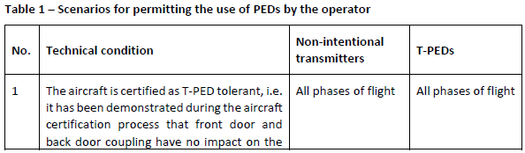
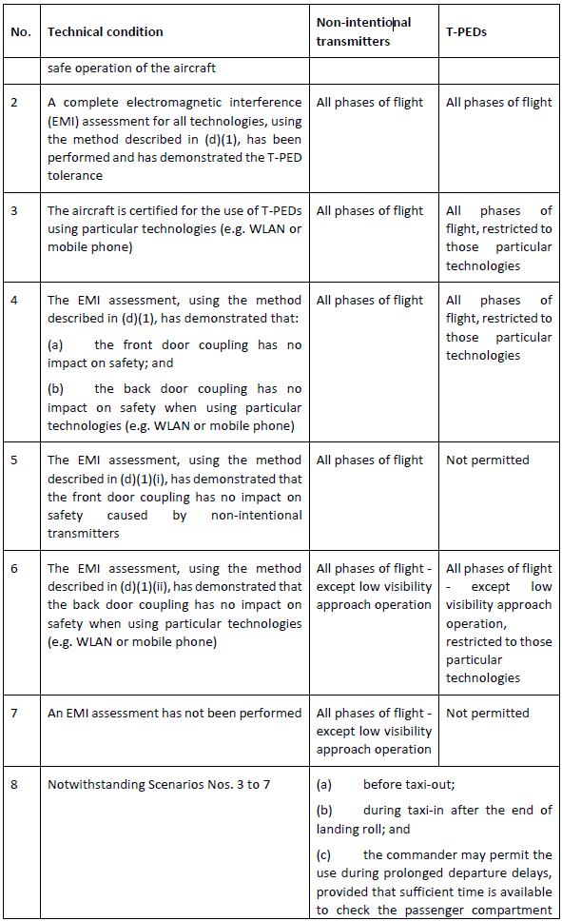
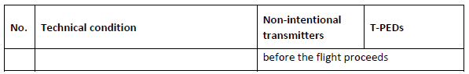
(d) Demonstration of electromagnetic compatibility
 | Bilaga nummer: |  | TS notering:
(1) EMI assessment at aircraft level
The means to demonstrate that the radio frequency (RF) emissions (intentional or nonintentional) are tolerated by aircraft systems should be as follows:
(i) to address front door coupling susceptibility for any kind of PEDs:
(A) EUROCAE, ‘Guidance for the use of Portable Electronic Devices (PEDs) on Board Aircraft’, ED-130A / RTCA DO-363 ‘Guidance for the Development of Portable Electronic Devices (PED) Tolerance for Civil Aircraft’, Section 5; or
(B) EUROCAE, ‘Aircraft Design and Certification for Portable Electronic Device (PED) Tolerance’, ED-239 / RTCA DO-307A, Section 4; The use of RTCA, ‘Guidance on Allowing Transmitting Portable Electronic Devices (T PEDs) on Aircraft’, DO-294C (or later revisions), Appendix 5C; or RTCA DO-307 ‘Aircraft Design and Certification for Portable Electronic Device (PED) Tolerance’, (including Change 1 or later revisions), Section 4 may be
acceptable.
(ii) to address back door coupling susceptibility for T-PEDs:
(A) EUROCAE, ‘Guidance for the use of portable electronic devices (PEDs) on board aircraft’, ED-130A/RTCA DO-363, Section 6; or
(B) EUROCAE, ‘Aircraft Design and Certification for Portable Electronic Device (PED) Tolerance’, ED-239 / RTCA DO-307A, Section 3; or
(C) The use of EUROCAE, ‘Guidance for the use of Portable Electronic Devices (PEDs) on Board Aircraft’, ED-130, Annex 6; or RTCA DO-294C (or later revisions), Appendix 6D; or RTCA DO-307 (including Change 1 or later revisions), Section 3 may be acceptable.
 | Bilaga nummer: |  | TS notering:
(2) Alternative EMI assessment of controlled PEDs (C-PEDs)
(i) To address front door coupling:
(A) C-PEDs should comply with the levels as defined by:
(a) EUROCAE/RTCA, ‘Environmental conditions and test procedures for airborne equipment’, ED-14D/DO-160D (or later revisions), Section 21,
Category M, for operation in the passenger compartment and the flight crew compartment; and
(b) EUROCAE ED-14D/RTCA DO-160D (or later revisions), Section 21, Category H, for operation in areas not accessible during the flight.
(B) If the C-PEDs are electronic flight bags used in the flight crew compartment and if the DO-160 testing described in (A) identifies inadequate margins for interference or has not been performed, it is necessary to test the C-PED in each aircraft model in which it will be operated. The C-PED should be tested in operation on the aircraft to show that no interference with aircraft equipment occurs. Credit may be given to other aircraft that are similarly equipped (meaning in particular that they contain the same avionics equipment) of the same make and model as the one tested.
(ii) To address back door coupling susceptibility for C-PEDs with transmitting capabilities, the EMI assessment described in (1)(ii) should be performed.

